Wordcloud representation : **(Data Analysis)**

Tasks performed:

* + 1. Made a Wordcloud representation using python for the positive sentences from youtube comment data.

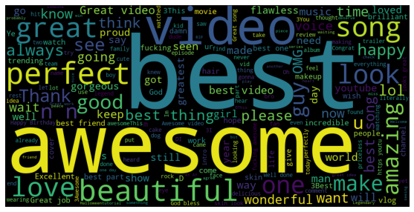

Similarly made for the negative sentences.

